API 调用 时序数据读写服务

创表
创表接口：
http://127.0.0.1:8886/manage/table/create
创表参数：
mode: 存储方式，column表示列存、row表示行存
bucket：数据库名
measurement：数据表名
rule：表列
id：列名
datatype：数据类型
isTag：是否为tag

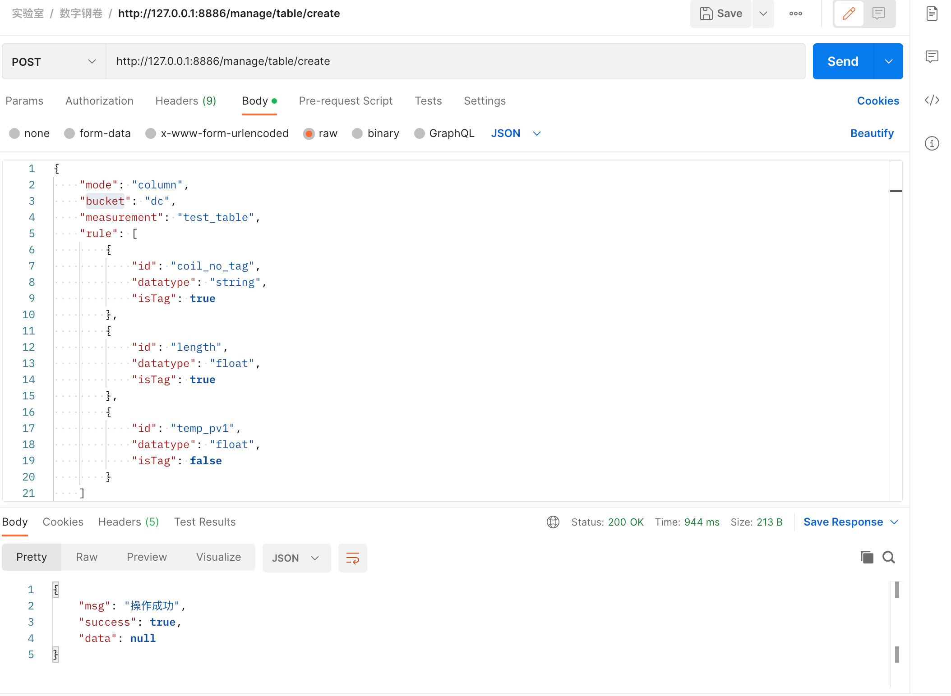
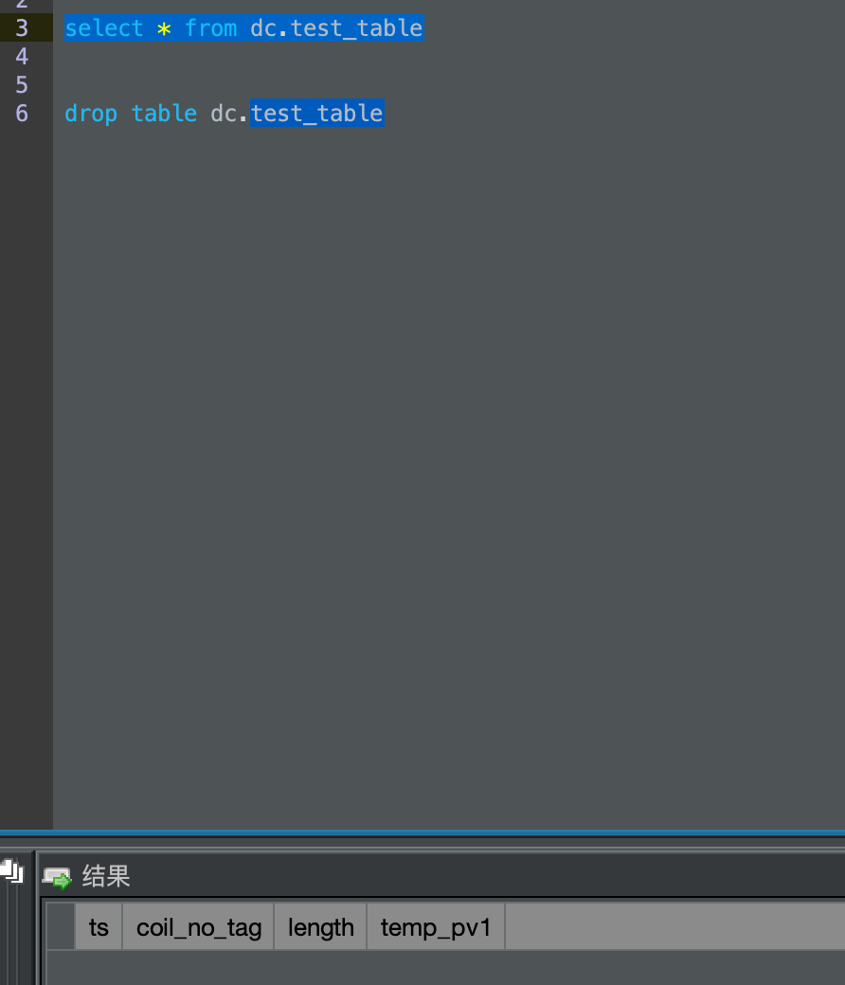
{
"mode": "column",
"bucket": "dc",
"measurement": "test_table",
"rule": [
{
"id": "coil_no_tag",
"datatype": "string",
"isTag": true
},
{
"id": "length",
"datatype": "float",
"isTag": true
},
{
"id": "temp_pv1",
"datatype": "float",
"isTag": false
}
]
}

写入数据
写入数据接口
http://127.0.0.1:8886/data/db/{database}/table/{table}/_column

写入数据参数
timestamp: 时间戳
isSameDeviceTime: true
mark：备注
values：参数值列表
id:列名
v:值
q：是否有效
t：时间戳
isTag：是否为tag
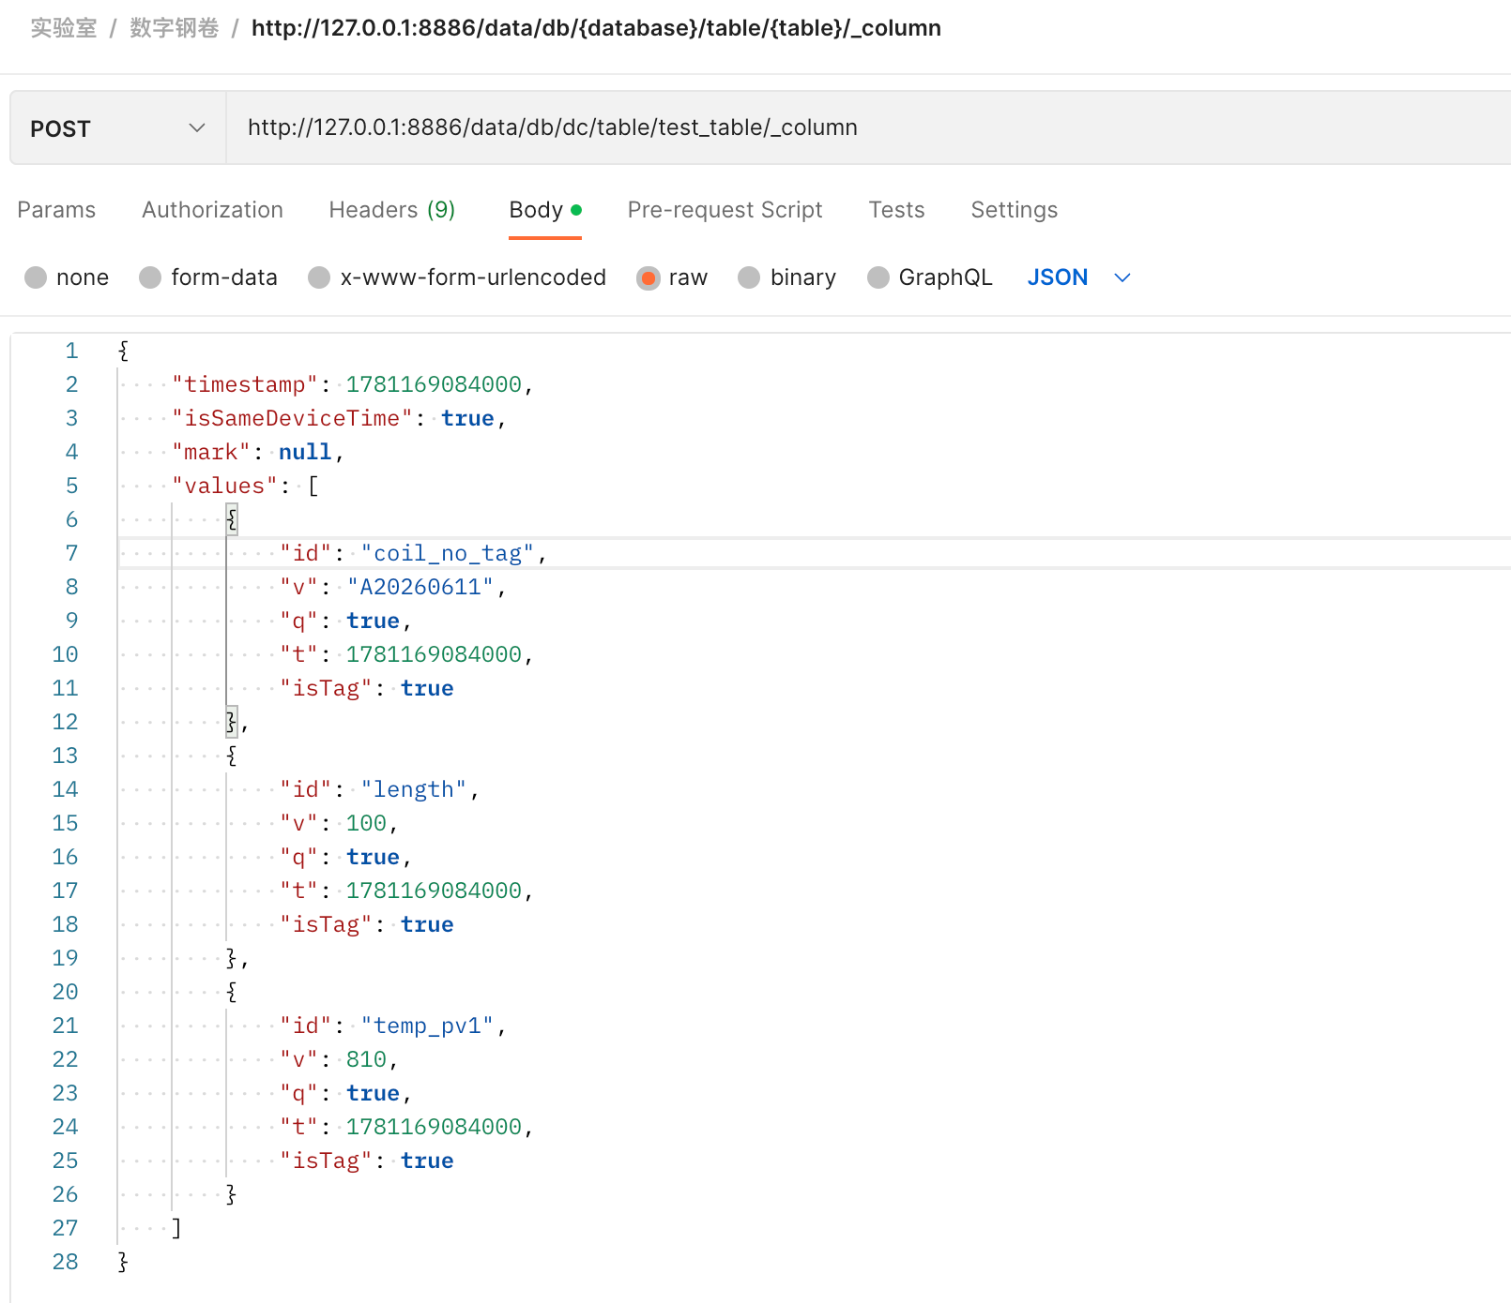
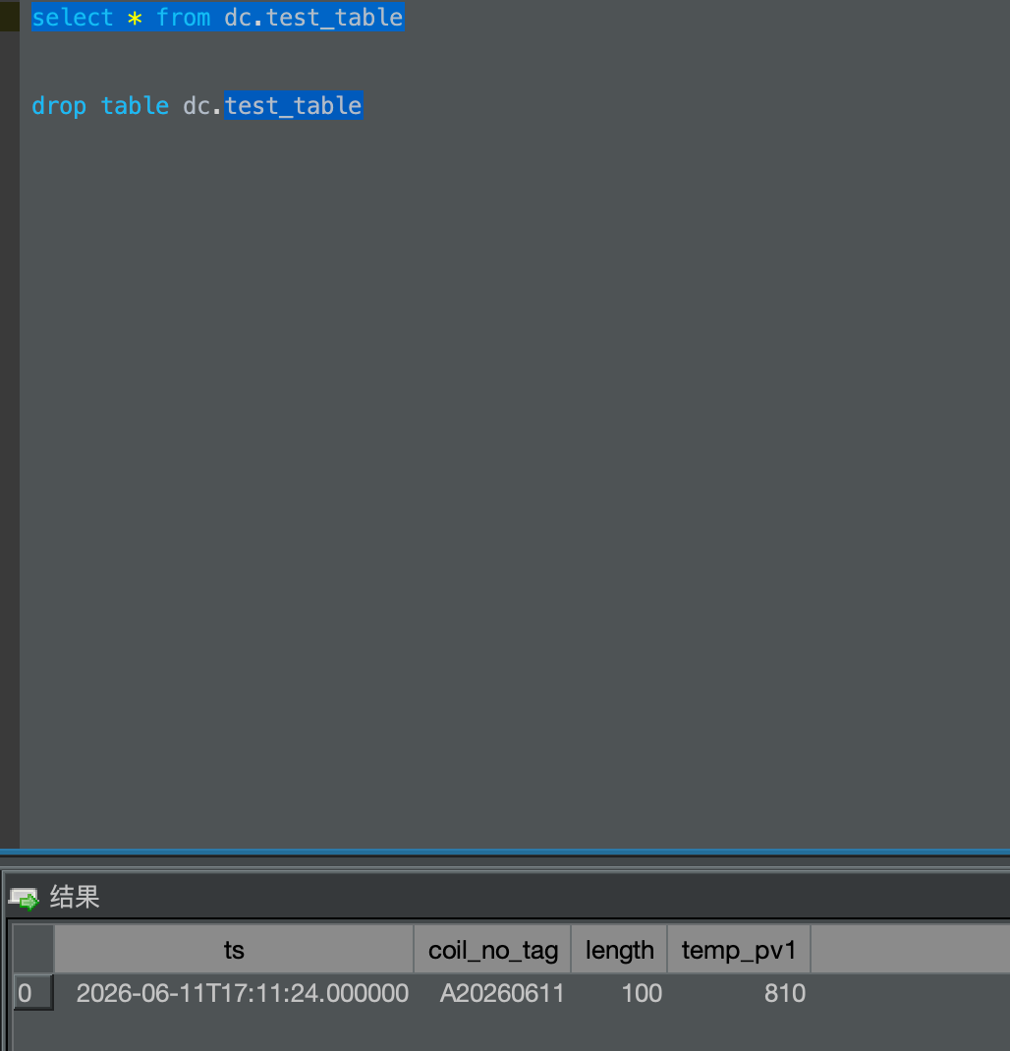

{
"timestamp": 1781169084000,
"isSameDeviceTime": true,
"mark": null,
"values": [
{
"id": "coil_no_tag",
"v": "A20260611",
"q": true,
"t": 1781169084000,
"isTag": true
},
{
"id": "length",
"v": 100,
"q": true,
"t": 1781169084000,
"isTag": true
},
{
"id": "temp_pv1",
"v": 810,
"q": true,
"t": 1781169084000,
"isTag": true
}
]
}

